Chapter5HW.R

jason

Tue May 03 10:53:36 2016

#Chapter 5 Homework  
  
###########Problem #1 ##############  
  
n = 500 # number of samples  
k1 = 10 # sample size of each sample  
k2 = 50  
  
#.a)  
  
X=runif(5000, min=0, max=5)  
xMatrix = matrix(X,k1,n)   
xmean = apply(xMatrix,2,mean)  
  
#Graph the mean of the samples  
hist(xmean)

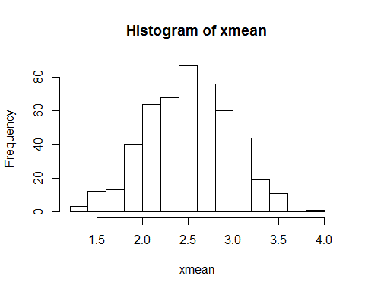

qqnorm(xmean)  
qqline(xmean)

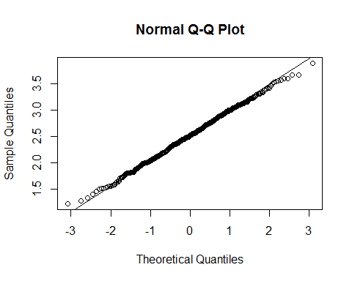

#Emperical Expected Value of samples means. Theoretical E(x) is 2.5. Compare the two values  
mean(xmean)

## [1] 2.513506

#Emperical Variance of samples means.Theoretical V(x) is .20833333. Compare the two values  
var(xmean)

## [1] 0.2165493

## For both the expected value and variance, the emperical values of the expected mean and variance of   
## samples means were extremely close. Using the central limit theorem, these two are very close  
  
X=runif(25000, min=0, max=5)  
xMatrix = matrix(X,k2,n)   
xmean = apply(xMatrix,2,mean)  
  
#Graph the mean of the samples  
hist(xmean)

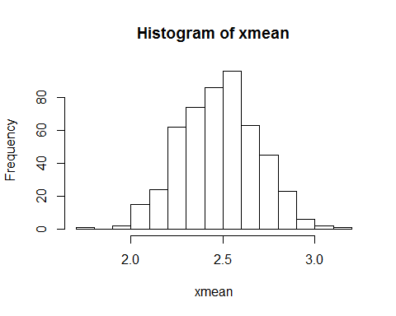

qqnorm(xmean)  
qqline(xmean)

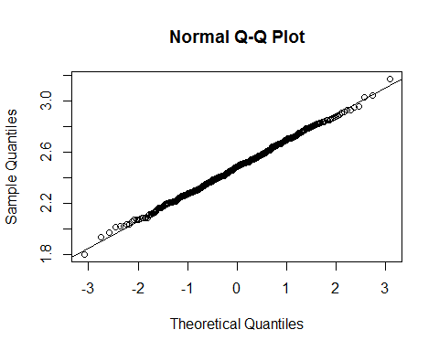

#Emperical Expected Value of samples means. Theoretical E(x) is 2.5. Compare the two values  
mean(xmean)

## [1] 2.48021

#Emperical Variance of samples means.Theoretical V(x) is .0416667. Compare the two values  
var(xmean)

## [1] 0.04332559

## For both the expected value and variance, the emperical values of the expected mean and variance of   
## samples means were extremely close. Using the central limit theorem, these two are very close  
  
  
#b. check page 173 for formulas  
  
  
X=rgamma(5000,4,scale = .5)  
xMatrix = matrix(X,k1,n)   
xmean = apply(xMatrix,2,mean)  
  
#Graph the mean of the samples  
hist(xmean)

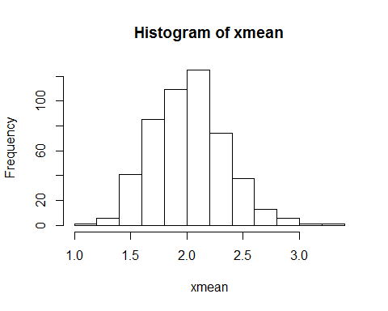

qqnorm(xmean)  
qqline(xmean)

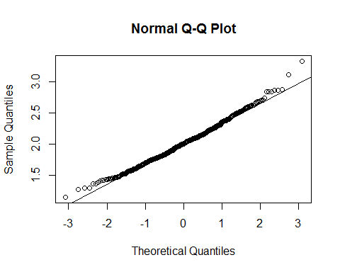

#Emperical Expected Value of samples means. Theoretical E(x) is 2.0. Compare the two values  
mean(xmean)

## [1] 2.016774

#Emperical Variance of samples means.Theoretical V(x) is .1 . Compare the two values  
var(xmean)

## [1] 0.1052671

## For both the expected value and variance, the emperical values of the expected mean and variance of   
## samples means were extremely close. Using the central limit theorem, these two are very close  
  
  
X=rgamma(25000,4,scale = .5)  
xMatrix = matrix(X,k2,n)   
xmean = apply(xMatrix,2,mean)  
  
#Graph the mean of the samples  
hist(xmean)

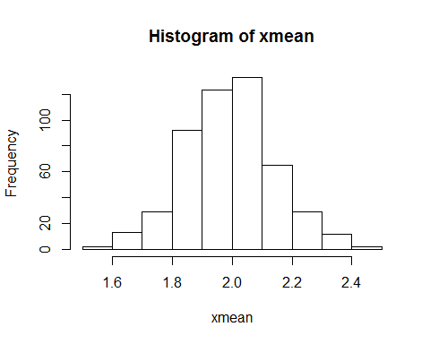

qqnorm(xmean)  
qqline(xmean)

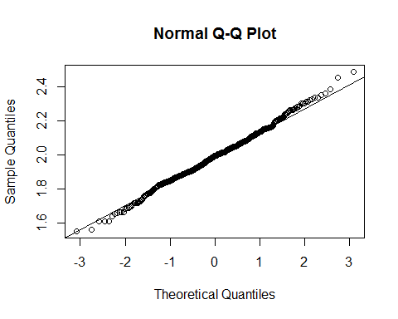

#Emperical Expected Value of samples means. Theoretical E(x) is 2.0. Compare the two values  
mean(xmean)

## [1] 1.990306

#Emperical Variance of samples means.Theoretical V(x) is .02 . Compare the two values  
var(xmean)

## [1] 0.02238366

## For both the expected value and variance, the emperical values of the expected mean and variance of   
## samples means were extremely close. Using the central limit theorem, these two are very close  
  
  
  
############### Problem 2 ###################  
  
lambda = 1/80  
  
#a.)  
vectorOne = c(rexp(1000,lambda))  
vectorTwo = c(rexp(1000,lambda))  
sumVectors = vectorOne + vectorTwo  
  
#calculate the probability that the sum of lifetimes are greater than 100 hours  
x = sumVectors[sumVectors>100]  
answer = (length(x)/length(vectorOne))^2  
answer

## [1] 0.417316

#b.)  
vOne = vectorOne[vectorOne>50]  
vTwo = vectorTwo[vectorTwo>50]  
lengthOne = (length(vOne)/length(vectorOne))^2  
lengthTwo = (length(vTwo)/length(vectorTwo))^2  
  
#Calculate the probability that both lasers will last longer than 12 hours  
answer = lengthOne * lengthTwo  
answer

## [1] 0.07853334